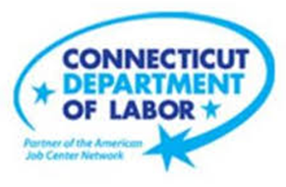

**NEW WEEKLY JOB POSTINGS FROM   
HELP WANTED ONLINE  
Office of Research**

**Week Ending December 17th, 2022: Health Care Gains Drive New Ad Increase**WETHERSFIELD, December 28th, 2022 – During the week ending December 17th, there were 6,841 new postings, up 431 new ads or +7% over the week. This overall increase is the net result of nine industries that increased by a combined 941 new ads and eleven industries that decreased over the week by 510 new ads. Health Care & Social Assitance accounted for two-thirds of the gain among increasing industries and was up 639 new ads over the week. Within Health Care & Social Assistance, Registered Nurses (+374 new ads) had the largest occupational job ads increase and the employer with the largest increase was Hartford Healthcare (266 new ads). Among the eleven industries with over the week new ad decreases, Administrative & Support Services (-63 new ads) was down the most. The graph below illustrates how statewide new job ads are up 20% from the late November low of 5,722 new ads.  
  
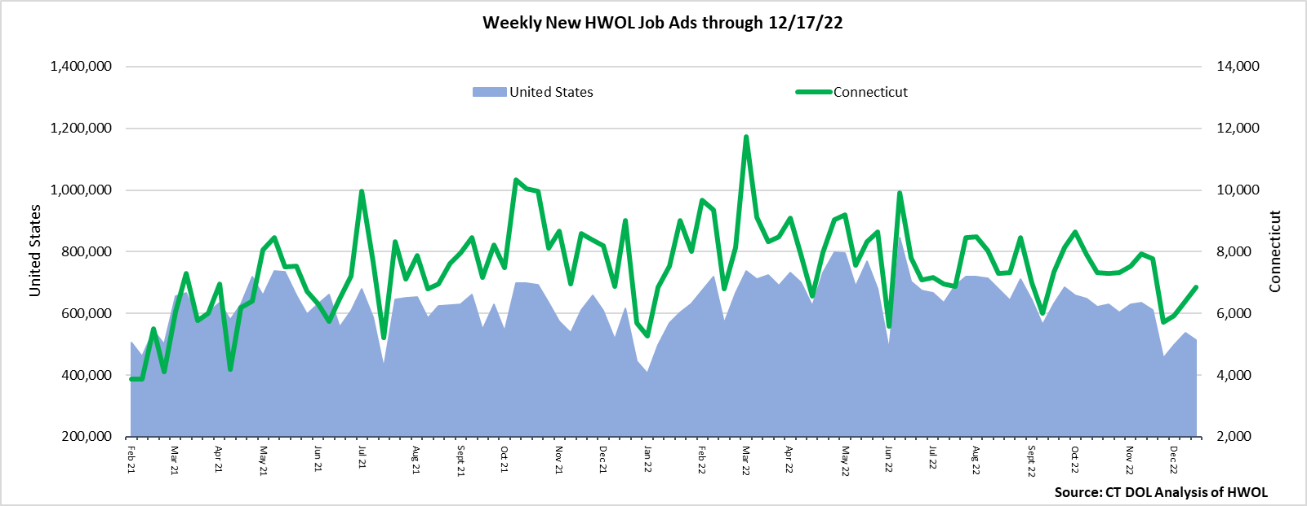  
**Industries** with the most new postings include Health Care & Social Assistance, Retail Trade and Manufacturing.

**Occupations** with the most new postings include Registered Nurses, Retail Salespersons, and Supervisors of Retail Sales Workers.

**Employers** with the most new postings include Hartford Healthcare, Community Health Center Inc., Connecticut Children’s Medical Center.

**The three industries with the most new job postings were:**

* **Health Care & Social Assistance** (2,304 new postings, +38% over the week)
* **Retail Trade** (627 new postings, +23% over the week)
* **Manufacturing** (569 new postings, -1% over the week)

   
 During the week ending December 17th, 2022, the 7% new ad total increase is the net result of increases in nine industries and decreases in eleven industries. Some of the largest percent increases include Health Care & Social Assistance (+38% or +639 new ads) and Retail Trade (+23% or -63 new ads). Over four weeks, new ads were down 12% or -932 new ads. Fifteen of twenty-one industries had four-week declines and seven had decreases of 100 new ads or more. The largest were Accommodation & Food Services (-53% or -240 new ads), Educational Services (-45% or -240 new ads), and Manufacturing (-23% or -171 new ads). Among increasing industries, Health Care & Social Assitance had a four-week increase of 42% or +685 new ads.  
  
  
 For more information on total job ads by industry for Connecticut and its labor market areas, see the monthly report available here: <https://www1.ctdol.state.ct.us/lmi/hwol.asp>

**New Job Postings by Occupation** 

**The occupations with the most new postings were:**

* Registered Nurses (718 new postings, +109% over the week)
* Retail Salespersons (157 new postings, -1% over the week)
* Supervisors of Retail Sales Workers (156 new postings, +22% over the week)

**Employers with the Most New Job Postings**  Employers with the most new job postings during the week were mostly in Health Care & Social Assistance, Manufacturing, and Retail Trade. The 25 employers shown above account for 28 percent of all new ads. 23 of 25 employers in the top 25 increased over the week and 2 decreased. Healthcare & Social Assistance accounted for 10 employers in the top 25. Hartford Healthcare had the largest increase over the week, up 266 new ads.   
  
**What is HWOL?**The **Conference Board Help Wanted Online**® Data Series (HWOL) measures the number of new, first-time Online job postings and jobs reposted from the previous month for over 16,000 Internet job boards, corporate boards, and smaller job sites that serve niche markets and smaller geographic areas. To view more HWOL data, go to: <https://www1.ctdol.state.ct.us/lmi/hwol.asp>